|  |  |
| --- | --- |
| Couch Potato Clip Art - Royalty Free - GoGraph  CouchPotato  An integrated food delivery concept | Summary  This assessment discusses a business proposal submitted by the founder of an upcoming food ordering and deliver app to its prospective investors. The proposal highlights the key aspects the company bases itself on. The objective is to illustrate the core of the company and how it aims on standing out amongst its sea of competitors.  The functional architecture and the order flow are explained using block diagrams and flowcharts. The flowchart and block diagram are vital for this article as they help break down the process and simplifies it for our readers.  Vrinda Arunachalam  Technical Writing assignment 1 |

**AGILYSYS**

**ASSIGNMENT - I**

**ONLINE FOOD ORDER AND DELIVERY PROCESS**

Hello Team,

Let me present to you an upcoming food ordering and delivery app named ***CouchPotato***. Please find the detailed description regarding our app encompassing the Functional Architecture, Order flow, Database, Kitchen Partner, Delivery and Payment Partners and some additional unique features which aren’t used by our established competitors- Swiggy, Zomato, FoodPanda and so on below.

* **Functional Architecture**-

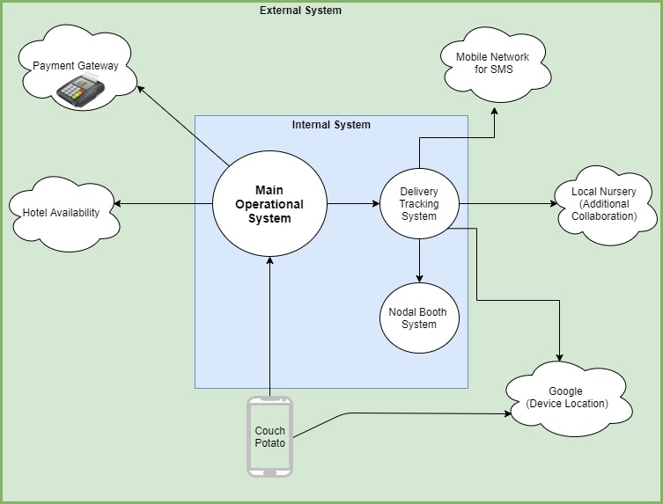

* **Order Flow** – Similar to the existing food apps we also operate using the basic functional architecture but with some special tweaks.

1. Customer downloads CouchPotato App from PlayStore and registers themselves.
2. Customer browses through CouchPotato app
3. Food items added to their cart.
4. Order placed using flexible payment options.
5. Order notified to the respective eateries – Owner receives the payment.
6. Our exclusive algorithm analyses and allots the delivery person
7. Estimated delivery time and tracking option using Google map is provided to the customer.
8. Updates of the order is provided additionally using SMS.
9. Delivery received by the customer and service completion notification activated.

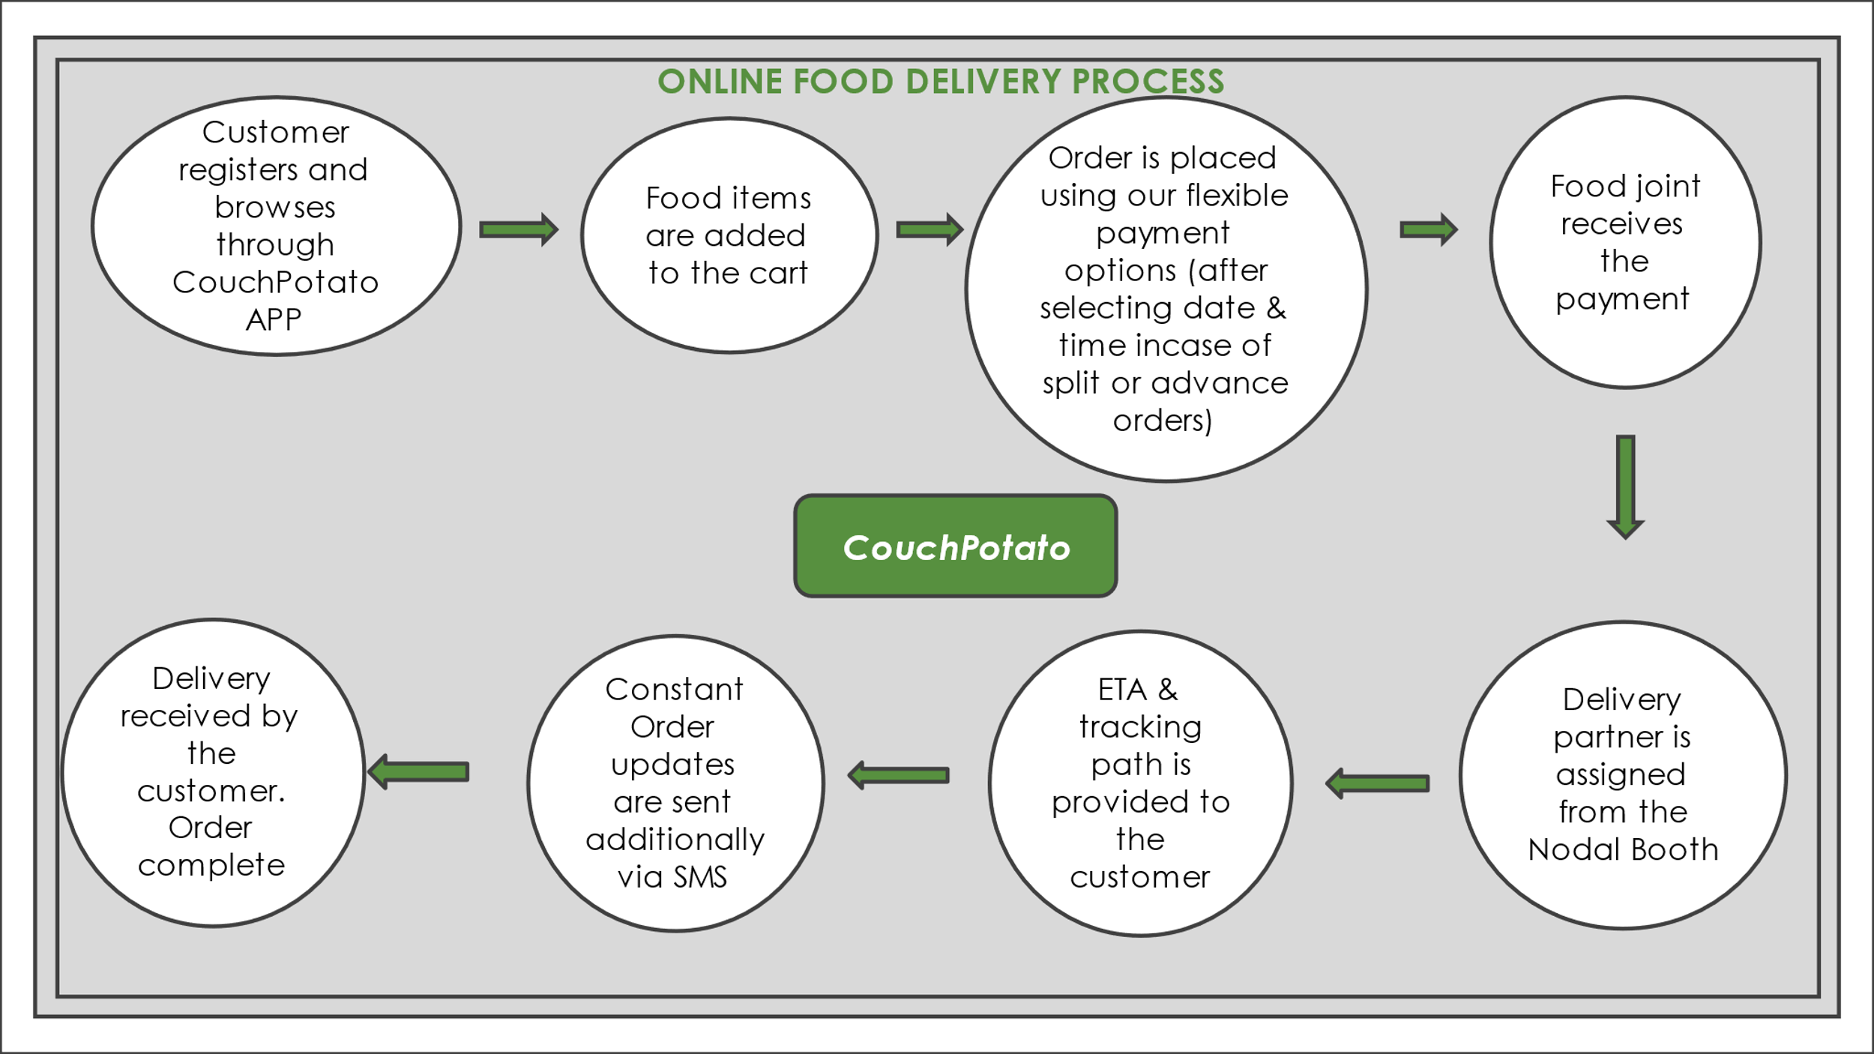

* **Database**- We plan to use Cloud as our database backup for smooth access and retrieval of data. Data backup can be done on a day to day basis by the end of the day. This we believe would help us solve customer queries or grievances efficiently.
* **Kitchen Partners** – Apart from partnering with the regular restaurant giants like our competitors, we plan on engaging with small or remote home-based cooks, very small eatery joints such as the roadside vendors to promote small businesses. For notifying such vendors who don’t possess smart phones, normal SMS can be used. This we believe in return would generate good word-of-mouth promotion for us.

Partnering with small home- based cooks can ensure promotion of healthy homely foods and contribute to the growth of amateur/home-based cooks. For example- your friendly neighborhood aunty who loves to prepare festival snacks and quick eats.

* **Delivery Partner**- As per our survey our competitors normally operate in one straight forward method- Notify the delivery person who arrives at the restaurant, picks the order and delivers at destination normally within 6-8 km radius.

1. We plan on expanding the order radius to increase our customer satisfaction.
2. We plan on providing our delivery partners with hot case delivery box to ensure that even our distant order customers enjoy piping hot food when their happy orders arrive.
3. We plan on setting up our CouchPotato nodal booths nearby to our kitchen partners. These booths will facilitate efficient rotation and distribution of our delivery agents aiming at reducing the time lag between ‘food prepared’ and ‘order picked’. CouchPotato booths will also be resting haunts for the delivery agents who wish to refresh, or are in between pickups.
4. Agents with long distance orders (above 10 km) can transfer delivery authority to agents available in the nodal booths enroute. We would be providing agents with unique delivery codes which while being transferred will be notified automatically to the customer as well as our database. Transfer of authority can free up the former deliver agent to pick up other orders enroute while the latter delivers the first order.

**ALGORITHM** – Our algorithm takes into account the availability of the delivery agents in the nearest Nodal booths along with the distance applicable to assign the delivery partner when the order gets placed.

* **Payment Partner**- We aim on collaborating with major banks to provide maximum amount of payment options to our customers namely- debit cards/ credit cards, UPI- Google, BHIM, Paytm, PhonePay, Sodexo etc. Apart from these Cash on Delivery will also be available to our customers. Swiping machines at doorsteps can also be provided to our customers unlike our competitors. This is for the people who want to pay using card but not via online transaction. Request can be placed while ordering and the delivery agent can be provided card machine for such cases.
* **Special Features**- We have enlisted the following points which makes us special and different from our competitors.

1. We have designed CouchPotato App in such a way that it can be a navigators’ paradise! We give our customers the luxury to explore the app with the utmost ease.

Hence, we have broken down the app into various tabs

* **Junk Lovers**- For a foodie who craves fried/ roasted mouthwatering cheat meals, this is the tab to tap. This tab enlists all the droolworthy pizzas, pastas, fries, burgers, fritters etc. available to the user from various outlets.
* **Calorie Counters**- Taking a complete 180 from the previous, this tab is for the food lovers who want to dig in delicious food but aim to keep their calories in check. Calorie counters tab will consist of variety of healthy and yummy options available out there along with their descriptive calorie count
* **Home-based Meal**- This tab will encompass all the home-based meal options partnered with home-based cooks. This is for all those who miss ‘Ghar ka khana / Veetu Saapadu’ or simply those who want to eat out but don’t want restaurant heavy food.
* **Binge Eaters**- Welcome to work from home binging dive! For foodies and busy bees who want to work on their spreadsheets while binging on some droolworthy cookies, this is what to need to tap.

From puff pastries to vada pav and caramel popcorn to paniyarams this tab comprises of all the little eats from various cuisines which the customer can binge on.

1. Our search engine allows the customer to pick their favorite food via various methods. They can input the dish name, restaurant name or cuisine to land up where desired.
2. CouchPotato also offers the customers the option to make dining reservations at their favorite joints.
3. CouchPotato unlike our competitors allows our customers to place advance orders for special occasions. Also, we have included 3 days/weekly/monthly meal plan option. For further convenience of our customers we have included customization which allows them to choose and make their own meal schedule.
4. CouchPotato allows customers to enter special requests or mention any food allergies while placing the order.
5. Another important and unique feature provided by CouchPotato will be the option of Split Ordering.

**SPLIT ORDERING**- If a customer wants to order multiple items but they don’t fall under the menu of same restaurant, they can pick the food items from different joints under the same Order. This ensures hassle free order placement and better customization as the customer can pick the suitable time for different orders.

1. CouchPotato also simplifies addressing grievances or complaints by incorporating chat box (not just restricted to robotic options), suggestion box and review box. Customer care no.is also provided under the Contact us tab in the App.
2. We aim to partner up with small Nursery vendors to provide our customers special offers like ‘orders above certain amount contains free small indoor/outdoor plant’ for the betterment of our planet.

We would like to conclude by saying that we want to establish a business which is not only profitable but also brings smiles on to people’s faces. **‘HAPPY TUMMY, HAPPY ME’**

**-Vrinda Arunachalam**